Serial Interfaces Lab
Practice 1 - UART

This lab will help you to remember some concepts seen in previous courses such as inputs, outputs, keypad, ADC and the introduction to UART seen in class.

The lab will be divided into 4 parts, described as follows:

Part 1 - Theory
This first part will consist of doing some calculations to determine the Serial Baud Rate (SBR) value for different standard values for the Baud Rate.

For all calculations, assume a clock frequency of 41.94 MHz and an OSR value of 15. Use the following formula:
$Baud Rate = \frac{Clock Source}{(OSR+1)*SBR}$

For each baud rate, calculate the SBR value and determine the corresponding BDH and BDL register values.
Round SBR to the nearest integer. After obtaining the integer SBR, calculate the actual baud rate obtained and its percentage error.

Baud rate | SBR (decimal) | SBR (hex) | BDH (hex) | BDL (hex) | Actual Baud rate | Error (%)
4800 | 546 | 0222 | 02 | 22 | 4,800.82 | 0.017%
9600 | 273 | 0111 | 01 | 11 | 9,601.648 | 0.017%
19200 | 137 | 0089 | 00 | 89 | 19,133.211 | 0.347%
38400 | 68 | 0044 | 00 | 44 | 38,547.794 | 0.384%
115200 | 23 | 0017 | 00 | 17 | 113,967.391 | 1.069%
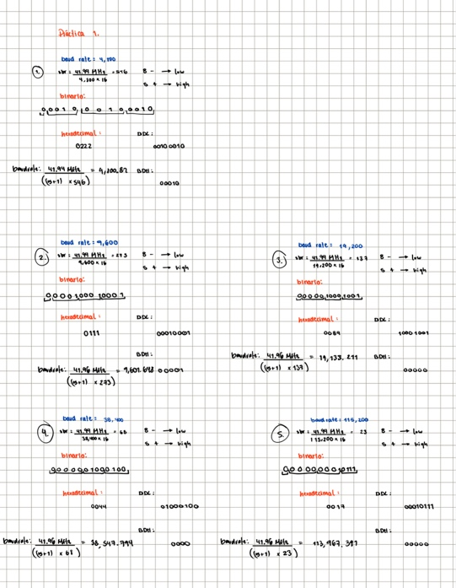
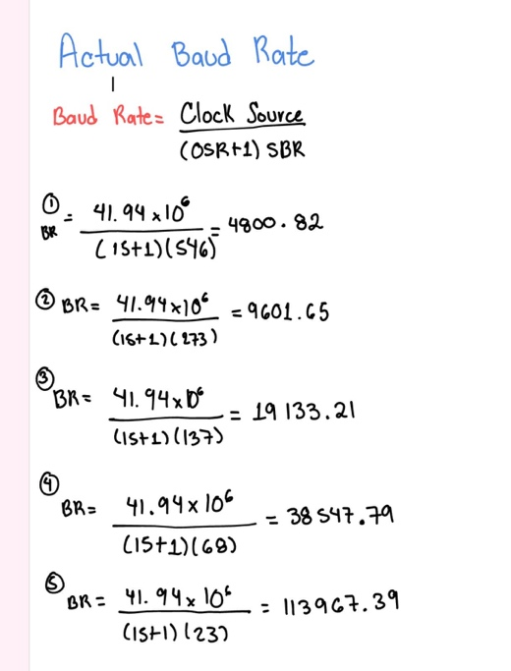
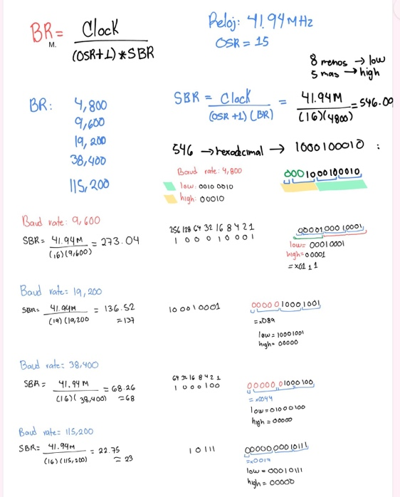

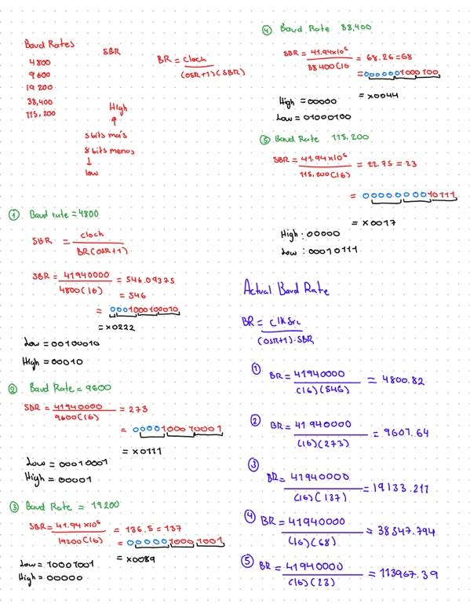

For Parts 2–4, use the following UART configuration:
- Baud rate: 115200 baud
- Data bits: 8
- Parity: None
- Stop bits: 1
- UART: UART0
Use the115200-baud configuration calculated in Part 1.

Part 2 - Examples
Implement the UART transmission and reception examples presented in class. Verify communication between the KL25Z and your computer using a serial terminal.
Demonstrate both:
- Transmission: KL25Z → Computer -> github
- Reception: Computer → KL25Z-> github

Upload screenshots showing that both directions of communication work correctly
Part 3 - UART Peripheral Control and Monitoring
In this part, you will implement a peripheral control and monitoring system using UART. You must connect the keypad, two push buttons, and an analog input such as a potentiometer.

The system must display the following main menu on the computer's serial terminal:

================================
KL25Z UART SYSTEM
================================
Commands:
L - LED control
A - Read ADC
K - Read keypad
B - Button status
================================

The user must select an option by sending the corresponding character from the computer.

- L - LED Control

LED control
1 - Red
2 - Green
3 - Blue
0 - All OFF

Turn ON the corresponding LED when 1, 2, or 3 is received. When 0 is received, turn OFF all LEDs. After each command, send a confirmation message through UART like Green LED ON

- A - ADC Monitoring

Continuously read the ADC and periodically send the result through UART. The message must include the ADC value and the corresponding voltage. Update the reading every 500 ms.

ADC Value: 2874
Voltage: 2.32 V

- K - Keypad

Continuously scan the keypad. Whenever a key is pressed, send its value through UART.

Press a key:
Key pressed: 8

Press a key:
Key pressed: 2

- B - Button Monitoring

Continuously monitor both push buttons. Whenever the state of either button changes, send the updated status through UART.

Button 1: PRESSED
Button 2: RELEASED

- Returning to the Main Menu
All submenus must remain active until the character Q is received from the computer. When Q is received, exit the current submenu and display the main menu again.

If an invalid command is received, display an error message and remain in the current menu.

Invalid command.
Please select an option:

Evidencia -> github

Part 4 - Interruptions
Modify the last code to use interruptions instead of polling for the reception of data.

Only the UART reception mechanism should be changed. The functionality of the system must remain the same as in Part 3.

The UART receiver interrupt must be used to detect incoming commands from the computer. Do not use polling to check the UART receive flag.

Upload your code and a link to a video of the system working correctly.

